Journal of Engineering Technology and Applied Physics

Exploring Neural and Generative Models for Occluded Face Recognition
Pei-Luo Lee ¹,Siew-Chin Chong ², Lee-Ying Chong ³, Yin-Ben King⁴
1,2,3Faculty of Information Science and Technology, Multimedia University, Jalan Multimedia, 63100 Cyberjaya, Malaysia
*Corresponding author’s email address: chong.siew.chin@mmu.edu.my, ORCiD: 0000-0003-0421-4367
https://doi.org/10.33093/jetap.20XX.X.X
Manuscript Received: 14 June 2025. Accepted: 23 December 2025. Published: 16 January 2026

Abstract - Lower-face occlusion remains a major challenge for face recognition because the nose, mouth, and chin contain identity information that may be hidden by masks, hands, or other occluders. This study investigates an occluded face recognition method that combines mask-restricted reconstruction using DE-GAN with confidence-based hybrid selection. The system detects and aligns the face, estimates the occluded lower-face region, reconstructs content only within the mask, and performs identity recognition using the VGGFace2 FaceNet recognizer with k-nearest-neighbour gallery scoring. CelebA [2] and VGG-Face2 [3] were used for training and development, whereas the LFW-derived processed_lfw closed-set protocol was used exclusively for evaluation. The same 2,115 samples were assessed under clean, masked, reconstructed, and hybrid conditions. Rank-1 accuracy decreased from 97.97% under clean conditions to 66.71% under masked conditions. Direct recognition of reconstructed images achieved 64.02% Rank-1 accuracy despite a high SSIM of 0.9369, indicating that structural similarity did not prevent identity drift. Confidence-based hybrid selection achieved 74.61% Rank-1 accuracy, improving on the masked baseline by 7.90 percentage points. Mean identity similarity was 0.6032. Recognition-only processing reached 8.99 FPS, compared with 1.89 FPS for reconstruction followed by recognition. These results show that visually plausible reconstruction is not sufficient for reliable recognition. Generated facial content should be accepted only when the recognition evidence indicates a clear identity benefit.

Keywords— Occluded Face Recognition; Face Reconstruction; Identity Preservation; FaceNet; DE-GAN; Hybrid Recognition

INTRODUCTION
Face recognition is widely used for authentication, surveillance, identity search, and hu-man-computer interaction. Its development has been supported by large-scale datasets, discriminative embedding learning, and deep recognition backbones that produce compact identity representations. Contemporary systems can achieve high accuracy on clean or near-clean images, but their assumptions become less reliable when part of the face is occluded and identity cues are unavailable.
Lower-face occlusion is particularly challenging. Masks, hands, scarves, and rectangular panels can cover the nose, mouth, and chin, all of which contribute identity-specific geometry and texture. Although the eyes and forehead remain visible, different individuals may exhibit similar up-per-face characteristics. The resulting ambiguity can shift the probe embedding towards an in-correct gallery identity, even when the recognizer performs well on clean images in closed-set identification.
The distinction between verification and identification further complicates the problem. Verification determines whether two images depict the same person, whereas closed-set identification must rank the correct identity among multiple gallery candidates. A small embedding shift may therefore change the nearest identity even when a reconstructed lower face appears plausible. Rank-1 identification under lower-face occlusion consequently tests identity preservation more directly than visual reconstruction quality alone.
Current methods broadly follow two directions. Recognition-oriented approaches suppress corrupted features, emphasize visible regions, or adapt embeddings to occlusion. Reconstruction-oriented approaches estimate the missing facial content from the visible region. Each ad-dresses part of the problem. Recognition without reconstruction discards potentially recoverable evidence, whereas unconditional reconstruction may introduce a plausible but identity-inaccurate mouth or chin.
Reconstruction is attractive because it attempts to recover identity evidence that the recognizer cannot observe, but the hidden lower face is not fully determined by the visible upper face. A generator optimized for smooth or average completion may produce a realistic mouth or chin that changes identity-sensitive attributes such as lip shape, mouth width, chin geometry, or lower-face texture. This identity drift can move the embedding away from the correct identity despite high visual quality, motivating the confidence-based hybrid selection used in this study.
The proposed system combines mask-restricted reconstruction with confidence-based hybrid selection. Rather than replacing every masked probe with its reconstruction, the system compares the recognition confidence obtained from both inputs. The reconstructed result is accepted only when it provides sufficiently stronger identity evidence. Clean, masked, reconstructed, and hybrid recognition are evaluated under one processed_lfw closed-set protocol, enabling a controlled analysis of reconstruction and selection.
The scope is deliberately limited. The study does not claim to solve every form of occlusion, introduce a new large-scale dataset, or propose a new recognition backbone. It addresses a narrower methodological question: when a lower-face reconstruction is available, should the recognizer trust it? Unconditional use may overwrite reliable evidence, whereas rejecting every reconstruction may discard recoverable identity information.
The study makes four contributions:
- A mask-restricted reconstruction framework using DE-GAN for lower-face occlusion, designed to preserve original identity evidence outside the detected mask.
- A confidence-based hybrid selection that selects reconstruction only when it provides a sufficient recognition advantage over the masked input.
- An empirical analysis of identity drift through the relationship among SSIM, identity similarity, and recognition performance.
- A controlled comparison of clean, masked, reconstructed, and hybrid recognition under the same processed_lfw closed-set protocol.

LITERATURE REVIEW
The literature is organized around embedding-based face recognition, occlusion-aware recognition, generative reconstruction, hybrid generation-recognition methods, domain adaptation, and face image quality assessment. This thematic structure supports a critical analysis of the research gap rather than a paper-by-paper catalogue.

Embedding-Based Face Recognition
The recognition branch of the proposed system follows the embedding-based paradigm. LFW established a widely used benchmark for face verification under realistic variations in pose, ex-pression, and illumination [1]. CelebA provides large-scale variation in facial appearance and at-tributes that is useful for reconstruction training and development [2]. VGGFace2 extends this scale through broad pose, age, and identity diversity, supporting the development of robust pretrained recognition models [3]. Recent JIWE research has also investigated deployable biometric recognition across face and periocular modalities under challenging real-world conditions, further demonstrating the importance of robust feature representations for practical recognition systems [4].
FaceNet formulated face recognition as metric learning, placing images of the same identity closer together in an embedding space than images of different identities [5]. Related work published in JIWE further demonstrated the effectiveness of FaceNet and VGGFace embeddings within a linear-fusion framework, reinforcing the robustness of deep facial embeddings for challenging face recognition tasks [6]. This representation supports closed-set gallery matching through cosine similarity or nearest-neighbor scoring. Its discrimination nevertheless depends on the available facial evidence. Lower-face occlusion can shift the probe embedding even when the upper face remains clearly visible.
The embedding literature also cautions against treating clean-image accuracy as evidence of occlusion robustness. Missing lower-face information is not equivalent to ordinary pose or illumination variation in LFW, CelebA, or VGGFace2. A recognizer may perform well on clean LFW-style images yet rank the correct identity poorly when the mouth and chin are hidden. This distinction motivates evaluation under clean, masked, reconstructed, and hybrid conditions.
Quality-aware embedding methods provide a complementary perspective. MagFace relates feature magnitude to face-image utility [7], while SER-FIQ estimates quality through stochastic embedding robustness without additional quality labels [8]. Fu et al. compared general and face-specific quality metrics for recognizers including FaceNet on BioSecure, LFW, and VGG-Face2, and found that recognition-oriented utility measures were more informative than general image-quality measures [9]. These studies support evaluating a reconstruction by its identity utility rather than appearance alone.
This distinction is especially relevant to reconstructed faces. A smooth, well-aligned, skin-coloured patch may score highly on a structural or perceptual metric while remaining a poor recognition sample because its local geometry changes the embedding. Face utility research therefore provides a conceptual link between image restoration and recognition evaluation.

Occlusion-Aware Recognition
Occlusion-aware recognition methods seek robustness by modifying the extraction or weighting of identity features. AMOFR uses generated occluded samples, knowledge distillation from an unoccluded teacher, and a visual-language-guided occlusion adapter to address multiple occlusion types [10]. FROM learns feature masks that suppress corrupted CNN activations without reconstructing the image [11]. OAM-Net combines an occlusion-aware subnetwork with attention to visible discriminative regions [12].
These methods show that robustness can improve without explicit image reconstruction. Feature-space processing avoids some computational costs and identity risks associated with generation. Its effectiveness, however, still depends on the discriminative value of the visible region, and performance may remain limited when the available identity evidence is sparse.
Recognition-only methods can suppress corrupted features, but they do not test whether the missing region can be restored usefully. Moreover, many occlusion-aware models are evaluated under method-specific training distributions, occlusion classes, or verification protocols. Such results do not directly establish whether a reconstructed lower-face patch improves Rank-1 identification under one closed-set protocol.
Dataset- and mask-specific studies further show that occlusion generalization cannot be assumed. Wang et al. proposed an attention-based masked face recognition system supported by masked training variants [13]. Neto et al. examined transfer beyond masks to object and sunglasses occlusions, showing that performance depends strongly on the occlusion type and evaluation protocol [14]. A model learned for one occlusion distribution may therefore not transfer directly to other lower-face coverings.
Published masked-face systems commonly report verification accuracy, TAR at a specified FAR, or dataset-specific classification accuracy. The present study reports Rank-1 identification on the processed_lfw closed-set protocol. The cited results are consequently used to identify methodological trends and gaps, not to construct a direct leaderboard across non-comparable protocols.

Generative Reconstruction and Inpainting
Generative reconstruction estimates missing pixels rather than suppressing corrupted features. DE-GAN incorporates face-domain priors into GAN-based inpainting to produce structurally coherent completions [15]. FC-GAN uses symmetry-aware completion to improve facial consistency [16]. HiFaceGAN addresses face renovation under unknown degradations through collaborative suppression and replenishment [17].
These models demonstrate that generative methods can recover coherent facial appearance, but visual plausibility does not establish identity correctness. RG-DP-FICN addresses this uncertainty by using a reference image of the same identity to guide completion [18]. The need for subject-specific guidance indicates that texture realism alone is insufficient. Without a strong identity constraint, ambiguous lower-face regions may be completed with population-average patterns.
DE-GAN, FC-GAN, and HiFaceGAN improve visual reconstruction through domain priors, symmetry awareness, and multi-stage restoration, respectively. These mechanisms can produce a more coherent image without resolving the biometric task. Recognition requires the generated pixels to remain consistent with the subject's gallery identity; a completion may be globally plausible yet locally inconsistent with that identity.
Occluded face reconstruction is therefore both an inpainting problem and an identity-conditioned decision problem. Structural similarity, perceptual quality, and skin tone may improve while identity-sensitive features change. The present study evaluates this identity drift through recognition accuracy and embedding-based identity similarity.
This risk also motivates mask-restricted compositing. Editing pixels outside the occlusion can alter facial evidence that was already reliable. Wider blending may make a boundary smoother but can reduce identity similarity by changing visible features. The method therefore preserves original pixels outside the mask and applies reconstruction only to the occluded region.

Hybrid Recognition and Reconstruction
Hybrid approaches connect generation to the recognition objective rather than treating resto-ration as a purely visual task. DVG-Face uses dual variational generation to bridge heterogeneous sensing domains while retaining identity relationships [19]. FA-GAN applies disentangled augmentation to vary deformation attributes such as pose or occlusion while preserving identity at-tributes [20]. Malakar et al. address identity loss in masked-face reconstruction by retrieving and transforming a real lower-face region from the same subject [21].
Cross-domain adaptation research adds a further consideration. The source-data-free method in [22] treats real occluded recognition as target-domain pseudo-label denoising and does not require source data. Synthetic masks may differ from real masks, privacy panels, and other coverings. Occluded recognition must therefore address both missing identity evidence and domain shift.
DVG-Face and FA-GAN also show that synthesis can support recognition without recon-structing each probe at test time. The former bridges sensing domains, while the latter generates deformation-invariant training variation. The present system addresses a different decision: whether a generated lower-face patch should influence the recognition result for an individual occluded probe.
The proposed framework uses hybrid in this restricted decision-level sense: it compares masked and reconstructed recognition outcomes and keeps the masked result unless reconstruction pro-vides a sufficient confidence gain. This selective policy accepts generated evidence only when recognition confidence supports it, while avoiding a new recognition backbone or generative dataset.

Face Image Quality and Identity Preservation
Face image quality assessment is closely related to reconstruction-assisted recognition. A general image-similarity measure such as SSIM does not directly measure identity agreement in the embedding space. MagFace, SER-FIQ, and related FIQA studies show that recognition utility depends on how an image behaves within the recognition model, not only on its visual naturalness or smoothness [7]-[9].
The distinction is pronounced in lower-face reconstruction. The lips and chin occupy a small part of the image, so averaged or slightly displaced features may have a limited effect on SSIM. A recognizer may nevertheless respond strongly to these local changes in shape and texture. Identity similarity is therefore needed alongside SSIM when reconstruction is evaluated for recognition.
Face quality research also suggests that no single score captures every deployment requirement. An image may be suitable for human inspection yet provide different utility to recognizers with different embedding functions. The proposed evaluation therefore reports Rank-1 accuracy for identity decisions, SSIM for structural quality, identity similarity for embedding preservation, and FPS for computational practicality.

Research Gap
Three methodological tensions recur in the reviewed literature. The first concerns feature-space robustness versus pixel-space reconstruction. Occlusion-aware recognizers such as AMOFR, FROM, and OAM-Net suppress corrupted evidence, while DE-GAN, FC-GAN, HiFaceGAN, and RG-DP-FICN estimate missing pixels. These approaches address different parts of the occlusion problem and are not interchangeable.
The second tension concerns visual plausibility versus biometric identity. Lower-face completion is underdetermined: several plausible mouths or chins may be consistent with the same visible upper face. Identity-guided methods respond by adding reference images or identity-related constraints. The present study examines the same problem at the decision level by withholding reconstructed results when their identity evidence is weak.
The third tension concerns evaluation comparability. Published systems use different LFW variants, masked datasets, verification measures, TAR/FAR settings, and classification protocols. These choices suit their respective research questions but prevent direct numerical comparison. A controlled internal protocol is needed to isolate reconstruction effects while holding the recognizer and gallery constant.
Together, these tensions motivate a hybrid framework that links reconstruction to recognition-based decision making. The objective is neither to assume that reconstruction always helps nor to reject it because it can fail. The study instead measures how reconstruction changes recognition behavior and selects the input with stronger identity evidence.
The review therefore identifies a decision-level gap: few studies measure how reconstructed pixels affect identity recognition while comparing masked, direct reconstructed, and hybrid recognition under one controlled protocol. The proposed framework addresses this gap on the processed_lfw closed-set protocol by analyzing SSIM, identity similarity, recognition accuracy, and runtime together. Table 1 summarizes the reviewed themes and resulting gap.

Table I. Thematic synthesis of literature and resulting research gap
Theme | Representative studies | Main contribution | Remaining gap for this study
Embedding recognition | LFW, CelebA, VGGFace2, FaceNet [1], [2], [3], [5] | Large-scale benchmarks and identity embedding spaces | Occlusion changes the probe evidence available to the embedding model
Occlusion-aware recognition | AMOFR, FROM, OAM-Net, Neto et al., Wang et al. [10]-[14] | Suppress corrupted features or attend to visible regions | Does not directly restore lower-face identity evidence
Generative inpainting | DE-GAN, FC-GAN, HiFaceGAN, RG-DP-FICN [15]-[17] | Produces visually complete or structurally plausible faces | Visual quality can remain high even when identity drifts
Hybrid generation-recognition | DVG-Face, FA-GAN, Malakar et al., source-data-free adaptation [19]-[22] | Connects generation, augmentation, or adaptation with identity matching | Few controlled comparisons of masked, reconstructed, and hybrid decisions
Quality and identity preservation | MagFace, SER-FIQ, FIQA utility studies [7]-[9] | Relates image quality to recognition utility | SSIM alone is insufficient for identity-preserving reconstruction

RESEARCH METHODOLOGY

Overall Framework
The proposed framework comprises four stages: face preparation, mask-restricted reconstruction, embedding-based recognition, and confidence-based hybrid selection. Face detection and alignment precede estimation of the occlusion mask. Reconstruction is limited to the detected lower-face region, preserving all visible pixels outside the mask. The same recognition backend processes clean, masked, and reconstructed inputs so that differences can be attributed to the input condition.
The methodological contribution lies in how reconstruction is constrained and used, rather than in a new general-purpose inpainting model. Generated content is treated as candidate identity evidence, not as a guaranteed restoration. This design follows directly from the research gap: reconstruction may improve visual completeness while introducing identity drift.
The four evaluation conditions isolate distinct effects. Clean recognition provides the reference performance of the recognizer on the protocol. Masked recognition measures the effect of lower-face occlusion. Reconstructed recognition tests the direct use of generated lower-face content. The hybrid condition measures whether confidence-based hybrid selection can retain useful reconstructions while rejecting harmful ones.
Figure 1 summarizes the complete pipeline. Its defining feature is that reconstruction does not automatically replace the masked probe. Both candidates are recognized, and their confidence values determine the final identity prediction.
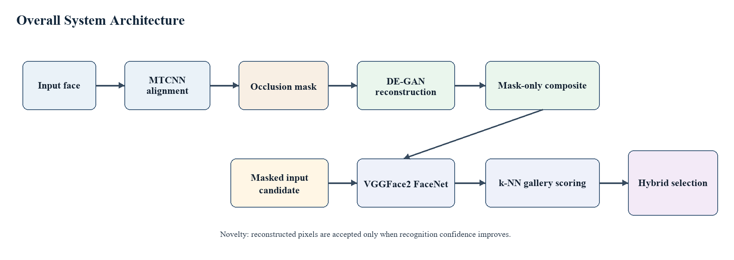
Fig. 1. The overall system architecture integrates mask-restricted reconstruction and confidence-based hybrid selection

Datasets and Protocol
Table 2 summarizes the roles of CelebA [2], VGGFace2 [3], and the LFW-derived [1] processed_lfw evaluation protocol. CelebA and VGGFace2 were used for training and development, while the processed_lfw closed-set protocol was reserved exclusively for final testing. It contains 2,115 samples from 423 identities and is evaluated as a closed-set identification benchmark. VGGFace2 supports the recognition model and development process but is not part of the test set.
Table II. Dataset roles and evaluation protocols
Dataset or resource | Role | Use in this study | Important note
CelebA | Training/development | Clean face appearance variation for reconstruction-related development | Not used as the final test protocol
VGGFace2 | Training/pretraining | Recognition model support and large identity variation | Supports embedding extraction; not the processed_lfw test set
processed_lfw | Testing only | Final closed-set lower-face occlusion protocol | 2,115 samples from 423 identities
Gallery index | Recognition reference | Stored embeddings used for k-NN identity matching | Held constant across clean, masked, reconstructed, and hybrid conditions

The processed_lfw closed-set protocol serves as a controlled internal benchmark rather than evidence of general deployment performance. Every condition uses the same identities and samples, avoiding comparisons across different datasets. The purpose is to measure recognition be-haviour across input conditions, not to claim direct state-of-the-art performance against studies with different protocols.

Mask-Restricted Reconstruction
The DE-GAN reconstruction branch receives an aligned occluded face and a binary mask. The generator predicts the missing facial content, but its output does not replace the complete face. Compositing modifies only pixels inside the mask because unnecessary edits to visible regions can reduce identity similarity.
For lower-face occlusion, the final configuration restricts reconstruction to the mouth-and-chin region and disables broad rectangular expansion. During development, patches that extended beyond the occluder overwrote identity evidence in the cheeks or lower nose. The implementation therefore favors conservative mask boundaries over visually broader blending.
Accordingly, reconstruction estimates missing evidence while retaining reliable original pixels: a visible boundary may be preferable to blending that alters unoccluded facial features.
Figure 2 illustrates the reconstruction workflow. The generator estimates content within the mask, after which strict compositing preserves the original image elsewhere to limit unintended identity drift.
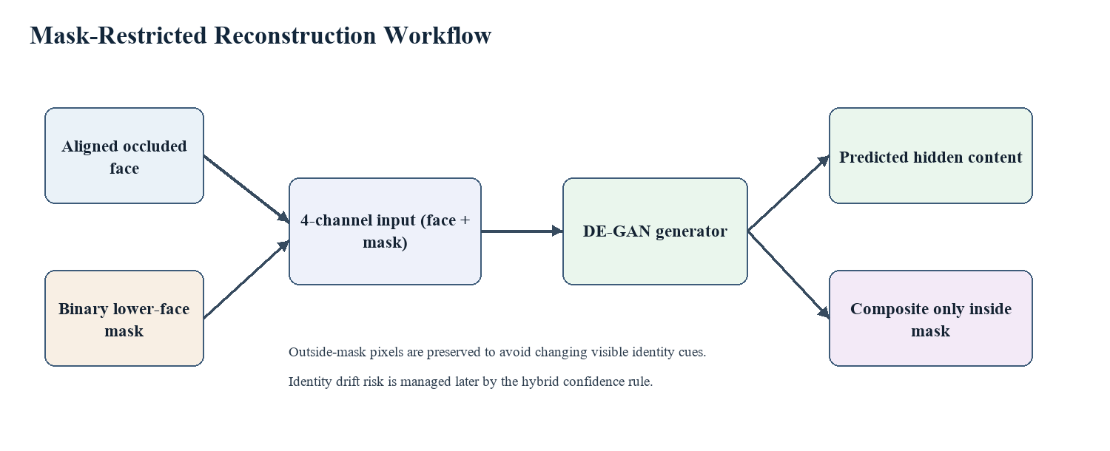
Fig. 2. The reconstruction workflow restricts compositing to the mask and preserves identity evidence outside it

Recognition and Confidence-Based Hybrid Selection
Recognition uses the VGGFace2 FaceNet recognizer with k-nearest-neighbour gallery scoring (k = 9). The same recognizer processes clean, masked, and reconstructed images. Holding the recognition model constant isolates the effect of each input condition.
The confidence-based hybrid selection rule compares recognition confidence for the masked and reconstructed inputs. The reconstructed prediction is selected only when its confidence exceeds the masked-input confidence by the defined margin of 0.04. Otherwise, the masked-input result is retained. This conservative rule treats the original visible face as the safer source unless reconstruction provides clearly stronger identity evidence.
The margin prevents unstable switching when confidence values are nearly equal, so generated pixels must show a clear benefit before changing the decision. Table 3 summarizes the final methodological configuration.

Table III. Final methodological configuration
Component | Final setting | Reason
Aligned face size | 112 x 112 | Matches the recognition and reconstruction pipeline input size
Reconstruction region | Occluded lower-face mask only | Preserves all visible identity pixels outside the mask
Mask expansion | Disabled for rectangular panel expansion | Reduces accidental editing outside the true occlusion
Recognition scoring | k-NN gallery scoring, k = 9 | Stabilises identity prediction using local gallery evidence
Hybrid margin | 0.04 confidence margin | Accepts reconstruction only when recognition confidence is clearly stronger
Selected checkpoint | identity_drift_finetune_4epoch, epoch 004 | Final reconstruction checkpoint used for the reported evaluation

Evaluation Measures
Closed-set recognition was measured with Rank-1, Top-3 and Top-5 accuracy, with the first one (Rank-1) being the more important as the top-ranked prediction has to be the correct identity. SSIM measures the quality of the structural reconstruction, while the closeness between the reconstructed embedding and the clean embedding is measured by identity similarity.
The time taken for recognition was compared to that taken for reconstruction followed by recognition. When the two paths are reported together, the trade-off between inaccuracy and accuracy is clear. Thus, the evaluation takes into account the recognition accuracy, the structural quality, the preservation of the identities and the computational efficiency.
The assessment is based upon the reported protocol and implemented system. Does not add extra dataset, training condition, or external benchmark. This boundary ensures that the experiments reported herein are reproducible and that the same can be compared to relevant reproducible and identity-preserving literature.
Each of the following expressions defines a principal measure: The final identification decision is denoted by Rank-1 accuracy, the similarity of the image's structure is denoted by SSIM, the embedding preservation is denoted by identity similarity, and the confidence-based hybrid selection rule determines when the reconstructed prediction replaces the masked-input prediction.
$$Rank-1 Accuracy=\frac{1}{N}\sum_{i=1}^{N}{I(y_{i}={\hat{y_{i}}}^{(1)}}) × 100\% ( SEQ Equation \backslash * ARABIC 1)$$
$$SSIM\left(x,y\right)=\frac{\left(2μ_{x}μ_{y}+C_{1}\right)\left(2σ_{xy}+C_{2}\right)}{(μ_{x}^{2}+ μ_{y}^{2}+C_{1})(σ_{x}^{2}+ σ_{y}^{2}+C_{2})} ( SEQ Equation \backslash * ARABIC 2)$$
$$s_{id}\left(x,y\right)=\cos\left(f\left(x\right),f\left(r\right)\right)=\frac{f{\left(x\right)}^{T}f(r)}{∥f\left(x\right)∥_{2}∥f\left(r\right)∥_{2}} ( SEQ Equation \backslash * ARABIC 3)$$
$${\hat{y}}_{hybrid}\left(x,y\right)=\left\{\begin{aligned} {\hat{y}}_{recon}, { c}_{recon}-c_{masked} ≥δ=0.04 \\ {\hat{y}}_{masked}, otherwise\end{aligned}\right. ( SEQ Equation \backslash * ARABIC 4)$$

Where $N$ is the total number of probe images; $I\left(∙\right)$is the indicator function; $y_{i}$and ${\hat{y_{i}}}^{(1)}$denote the ground-truth and predicted identities, respectively; $x$ and $r$ represent the reconstructed and reference images; $μ$, $σ_{}^{2}$ and $σ_{xy}$ denote the image means, variances and covariance; $C_{1}$and $C_{2}$ are stabilizing constants; $f(∙)$ denotes the face embedding extracted by the recognition model; $∥∙∥_{2}$ is the Euclidean norm; $y_{recon}$ and $y_{masked}$are the predicted identities from the reconstructed and masked images; $c_{recon}$ and $c_{masked}$ are the corresponding confidence score; and $δ$ is the confidence margin, which is set to 0.04.

Experimental Conditions and Reproducibility Rationale
The four-condition evaluation consists of the clean baseline, masking loss, direct reconstruction, and confidence-gated hybrid selection. The clean condition is a reference condition, the masked condition is a practical baseline, the reconstructed condition tests probes already completed, and the hybrid condition tests selective use based on confidence gain.
The same gallery and scoring are used for all conditions. This control is necessary due for two reasons: Rank-1 accuracy might change if the recognizer or the gallery changes, and you don't want the input to change the Rank-1 accuracy. By fixing the recognition backend, the impacts of occlusion, reconstruction and confidence based hybrid selection on identity ranking are separated.
The “mask-restricted compositing” rule also applies to the reconstruction. The generated output is not a complete face, but an edited version of the original image. The identity evidence of the visible regions remains original, only the masked region is estimated. This results in a more conservative reconstruction condition than the full-face synthesis.
The report of the run-time is made since the accuracy and feasibility must be considered jointly. Even if it offers better selected predictions, a reconstruction model with significant reduction in throughput may not be appropriate for an online deployment. The paths demonstrated with the FPS values are recognition-only and reconstruction-plus-recognition paths, but do not imply that the hardware is optimized or deployed.

RESULTS AND DISCUSSIONS
Table 4 shows the recognition accuracy on the processed_lfw closed-set protocol for 2115 samples. The clean condition is the reference condition, the masked condition is the cost of lower face occlusion, the reconstructed condition is the direct usage of generated content, and the hybrid condition is the confidence-based hybrid selection.
Table IV. Recognition results on the processed_lfw closed-set protocol
Condition | Correct / total | Rank-1 | Top-3 | Top-5 | Interpretation
Clean | 2072 / 2115 | 97.97% | 100.00% | 100.00% | Reference condition without synthetic lower-face occlusion
Masked | 1411 / 2115 | 66.71% | 76.22% | 78.49% | Lower-face occlusion removes identity evidence
Reconstructed | 1354 / 2115 | 64.02% | 77.73% | 81.51% | Visual completion alone does not prevent identity drift
Hybrid | 1578 / 2115 | 74.61% | 82.79% | 85.01% | Strongest internal result through confidence-based selection

Figure 3 visualizes the Rank-1 results. Reconstruction alone does not improve masked recognition, whereas confidence-based hybrid selection recovers a meaningful portion of the occlusion-induced loss.
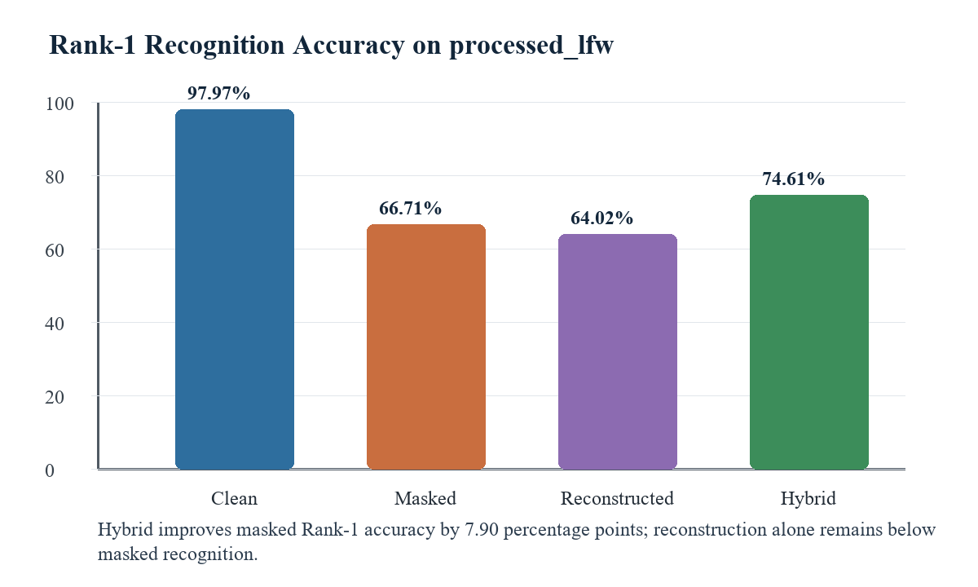
Fig. 3. The chart compares Rank-1 accuracy across clean, masked, reconstructed and hybrid conditions
Clean Rank-1 accuracy reaches 97.97%, confirming that the embedding and gallery-matching pipeline is effective when the full face is visible. Masking reduces Rank-1 accuracy to 66.71%, showing how strongly lower-face occlusion limits the available identity evidence. This decline is consistent with occlusion-aware research, which suppresses corrupted features or emphasizes visible regions because standard recognizers do not inherently handle missing facial information.
The masked Top-3 and Top-5 accuracies are 76.22% and 78.49%, respectively. The correct identity therefore remains in the shortlist for some probes even when it is not ranked first. Low-er-face occlusion often weakens or reorders the evidence rather than removing it entirely, leaving scope for a selective reconstruction to improve the final ranking.
Direct recognition of reconstructed images achieves 64.02% Rank-1 accuracy, slightly below the 66.71% masked result. However, reconstructed Top-3 and Top-5 accuracies (77.73% and 81.51%) exceed the masked scores (76.22% and 78.49%). Reconstruction can therefore add useful evidence without reliably placing the correct identity first. Small changes in lip shape, mouth width, chin geometry, or local texture can misorder the nearest gallery candidates even when the completed patch appears coherent. This mixed ranking behavior motivates a decision rule rather than unconditional use of the reconstructed input.
Confidence-based hybrid selection achieves 74.61% Rank-1 accuracy, a gain of 7.90 per-centage points over the masked baseline and the strongest internal result. The method retains the masked prediction unless reconstruction improves recognition confidence by the defined margin. Because the dataset, gallery, VGGFace2 FaceNet recognizer, and k-nearest-neighbor scoring remain fixed, the gain is attributable to this selection rule rather than a change in the recognition model or evaluation conditions. The result shows that reconstruction recovers useful identity in-formation for some probes but remains too variable for unconditional use.
Table 5 reports reconstruction quality, identity similarity, and runtime. Together, these measures explain why a visually convincing reconstruction can still reduce Rank-1 recognition.
Table V. Reconstruction quality, identity preservation and runtime
Metric | Value | Interpretation
Reconstructed SSIM | 0.9369 | High structural similarity and visually plausible reconstruction
Reconstructed identity similarity | 0.6032 | Moderate identity preservation; drift remains visible to the recogniser
Recognition-only speed | 8.99 FPS | Faster path when generation is not required
Reconstruction + recognition speed | 1.89 FPS | Generation adds substantial computational cost

Figure 4 presents representative evaluation examples. The completed lower faces appear plausible, but recognition still depends on whether the generated lips, mouth, and chin preserve the subject's identity.
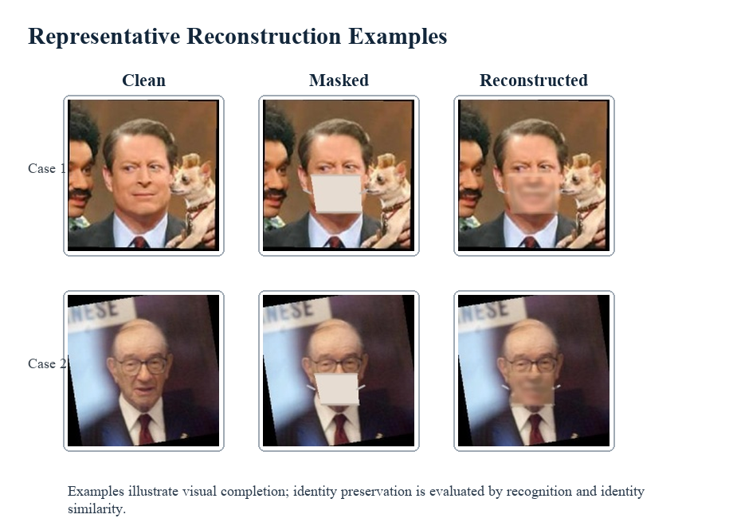
Fig. 4. Examples comparing clean, masked and reconstructed faces from the evaluation samples
The reconstructed images show good structural similarity with the reference images, with an SSIM of 0.9369 and the SSIM identity similarity of 0.6032. This is not a conventional visual-inpainting failure; rather, an averaged mouth or slightly altered chin can incur a small SSIM penalty while shifting the identity embedding. This means that visually plausible reconstruction does not necessarily mean the preservation of identity, as in the case of the identity-guided reconstruction, as in RG-DP-FICN [18] and Malakar et al. [21].
The results also agree with mask-restricted compositing. If the generator alters evident pixels, the preserved region and the generated region can be different from the identity. The proposed system is able to preserve the original pixels if there is no occlusion and only estimate the occlusion region, meaning that only reliable evidence is preserved.
A second trade-off concerns rzsuntime. When reconstruction is added, the system operates at 1.89 FPS compared to 8.99 FPS when recognition is added. The FPS values are not hardware metrics, but they illustrate that every probe would incur the cost of unconditional reconstruction if the cost of reconstruction was not subtracted from the cases where masked recognition is correct. Before activation of the reconstruction branch, therefore, a practical system should take into account recognition uncertainty and computational budget
Table 6 places the proposed results alongside selected cited studies. The comparison is con-textual because the studies use different datasets, occlusion types, protocols, and metrics.
Table VI. Contextual comparison and key methodological differences among selected cited studies
Study | Dataset/protocol/metric | Reported result | Key Difference / Contribution
Neto et al. (2022) [12] | LFW and Occ-LFW-style verification settings | 99.82% clean LFW; 91.13% Occ-LFW-2.0 | Recognition-only generalisation study; no reconstruction, identity-drift analysis, or unified four-condition comparison.
Liu et al. (2024) AMOFR [8] | LFW-MASK and related occlusion protocols | 96.25% accuracy on LFW-MASK | Occlusion-adaptive recognition without reconstruction or identity-preservation analysis.
Malakar et al. (2024) [19] | LFW-based reconstruction-assisted recognition | 98.00% LFW accuracy reported in the cited study | Uses subject-specific lower-face information and a different protocol; no unified four-condition test.
Proposed system | processed_lfw closed-set Rank-1 identification; 2,115 samples | Rank-1 Accuracy: Clean 97.97%, Masked 66.71%, Reconstructed 64.02%, Hybrid 74.61%; SSIM 0.9369; identity similarity 0.6032. | Controlled clean vs masked vs reconstructed vs hybrid comparison; identity-drift analysis; confidence-based hybrid selection under one processed_lfw protocol.

The contribution is presented in Table 6 and is not intended as a direct performance ranking or cross-study comparison. Feature-space methods such as AMOFR, FROM, and OAM-Net improve robustness, whereas methods such as DE-GAN, FC-GAN, HiFaceGAN, and RG-DP-FICN are reconstruction-based. The proposed system, however, examines whether generated facial content should influence the final identity decision. Its novelty lies in the controlled four-condition comparison together with an identity-aware confidence rule that links visual reconstruction to recognition utility.
Using the mean identity similarity of 0.6032, a more specific interpretation of the reconstruction results is obtained. The value indicates moderate agreement between reconstructed and clean embeddings because the upper-face information is preserved while part of the lower-face structure is recovered. This observation is consistent with the ranking results: reconstructed Top-3 and Top-5 accuracies improve over the masked condition, whereas Rank-1 accuracy decreases. Identity similarity therefore serves as an explanatory measure, while Rank-1 accuracy remains the primary measure of recognition performance.
The practical implication is one of cautious integration. Although visually plausible reconstruction may assist human inspection, biometric recognition requires identity-discriminative information. Experimental results indicate that reconstruction utility is heterogeneous: generated lower-face content provides useful evidence when it accurately reflects the subject's identity but becomes a competing signal when reconstructed mouth or chin features differ from the original appearance. If reconstruction were consistently harmful, confidence-based hybrid selection would not improve the masked baseline; conversely, if reconstruction were consistently beneficial, direct recognition of reconstructed images would outperform masked recognition.
The runtime difference between 8.99 FPS and 1.89 FPS further motivates adaptive and confidence-aware reconstruction pipelines. A practical two-stage framework could first perform masked recognition, estimate recognition uncertainty or face-image utility, and reconstruct only faces that are difficult to recognize. This observation highlights that selective reconstruction can improve recognition performance while reducing unnecessary computational cost, making confidence-based reconstruction a more practical strategy than unconditional reconstruction.

CONCLUSION
This study addressed lower-face occlusion, in which masks, hands, scarves, or panel-like coverings hide identity-bearing information in the nose, mouth, and chin. The central problem is not only whether missing pixels can be reconstructed, but whether generated pixels preserve the identity required by a biometric recognizer. A visually convincing completion may still change identity-sensitive lower-face details.
The proposed method combines mask-restricted reconstruction using DE-GAN, the VGGFace2 FaceNet recognizer, and confidence-based hybrid selection. Reconstruction is confined to the occluded mask so that visible facial evidence remains unchanged. Clean, masked, reconstructed, and hybrid conditions are evaluated with the same gallery and recognizer under the processed_lfw closed-set protocol.
The quantitative results distinguish visual quality from recognition utility. Clean Rank-1 accuracy is 97.97%, falling to 66.71% under masking. Reconstructed images achieve a high SSIM of 0.9369, yet direct reconstructed recognition reaches only 64.02% Rank-1 accuracy and mean identity similarity is 0.6032. High structural similarity therefore does not ensure that the generated lower face preserves the subject's identity.
Confidence-based hybrid selection achieves 74.61% Rank-1 accuracy, improving the masked baseline by 7.90 percentage points and providing the strongest internal result. The scientific contribution is the treatment of reconstruction as conditional identity evidence rather than an unconditional replacement for the occluded probe. Selection cannot correct the generator, but it reduces the impact of identity drift when the reconstructed candidate is not clearly stronger.
For practical deployment, the 8.99 FPS recognition-only path and the 1.89 FPS reconstruction-plus-recognition path also support selective reconstruction. Visually plausible completion is not necessarily identity-preserving; reconstructed content should be treated as conditional bio-metric evidence. The principal contribution is confidence-based hybrid selection, which retains useful reconstructions while limiting identity drift. Future work should priorities identity-aware reconstruction losses and ArcFace-style constraints, extend evaluation to quality-aware selection, verification protocols, real-mask datasets, and adaptive triggering. Identity preservation, rather than visual quality alone, should remain the governing objective.

ACKNOWLEDGEMENT
The authors received no funding from any party for the research and publication of this article.

AUTHOR CONTRIBUTIONS
Lee Pei Luo: Conceptualization, Methodology, Validation, Writing – Original Draft Preparation.
Siew-Chin Chong: Project Administration, Data Curation, Supervision, Writing – Review & Editing.
Lee-Ying Chong: Project Administration, Writing – Review & Editing.

CONFLICT OF INTERESTS
No conflict of interests were disclosed.

ETHICS STATEMENTS
The paper follows The Committee of Publication Ethics (COPE) guideline.

DATA AVAILABILITY
The datasets used in this study are publicly available. CelebA, LFW, and VGGFace2 can be accessed from their respective official repositories at https://mmlab.ie.cuhk.edu.hk/projects/CelebA.html, https://www.kaggle.com/datasets/jessicali9530/lfw-dataset, and https://www.robots.ox.ac.uk/~vgg/data/vgg_face2/, respectively.

REFERENCES
- G. B. Huang, M. Ramesh, T. Berg, and E. Learned-Miller, "Labeled Faces in the Wild: A Database for Studying Face Recognition in Unconstrained Environments," University of Massachusetts Amherst, Tech. Rep. 07-49, 2007.
- Z. Liu, P. Luo, X. Wang, and X. Tang, "Deep Learning Face Attributes in the Wild," in Proc. IEEE Int. Conf. Computer Vision (ICCV), 2015, pp. 3730-3738.
- Q. Cao, L. Shen, W. Xie, O. M. Parkhi, and A. Zisserman, "VGGFace2: A Dataset for Recognising Faces across Pose and Age," in Proc. IEEE Int. Conf. Automatic Face and Gesture Recognition (FG), 2018, pp. 67-74.
- J. Kim, T.-S. Ng, and A. B. J. Teoh, "Conditional Deployable Biometrics: Matching Periocular and Face in Various Settings," Journal of Informatics and Web Engineering, vol. 3, no. 3, pp. 302–313, 2024, doi: 10.33093/jiwe.2024.3.3.19.
- F. Schroff, D. Kalenichenko, and J. Philbin, "FaceNet: A Unified Embedding for Face Recognition and Clustering," in Proc. IEEE Conf. Computer Vision and Pattern Recognition (CVPR), 2015, pp. 815-823.
- R. Goel, M. Alamgir, H. Wahab, M. Alamgir, I. Mehmood, H. Ugail, and A. Sinha, "Sibling Discrimination Using Linear Fusion on Deep Learning Face Recognition Models," Journal of Informatics and Web Engineering, vol. 3, no. 3, pp. 214–232, 2024, doi: 10.33093/jiwe.2024.3.3.14.
- Q. Meng, S. Zhao, Z. Huang, and F. Zhou, "MagFace: A Universal Representation for Face Recognition and Quality Assessment," in Proc. IEEE/CVF Conf. Computer Vision and Pattern Recognition (CVPR), 2021, pp. 14225-14234.
- P. Terhorst, J. N. Kolf, N. Damer, F. Kirchbuchner, and A. Kuijper, "SER-FIQ: Unsupervised Estimation of Face Image Quality Based on Stochastic Embedding Robustness," in Proc. IEEE/CVF Conf. Computer Vision and Pattern Recognition Workshops (CVPRW), 2020.
- B. Fu, C. Chen, O. Henniger, and N. Damer, "A Deep Insight Into Measuring Face Image Utility With General and Face-Specific Image Quality Metrics," in Proc. IEEE/CVF Winter Conf. Applications of Computer Vision (WACV), 2022, pp. 905-914.
- Y. Liu, G. Luo, Z. Weng, and Y. Zhu, "Adaptive Face Recognition for Multi-Type Occlusions," IEEE Trans. Circuits Syst. Video Technol., vol. 34, no. 11, pp. 11400-11412, 2024.
- H. Qiu, D. Gong, Z. Li, W. Liu, and D. Tao, "End2End Occluded Face Recognition by Masking Corrupted Features," IEEE Trans. Pattern Anal. Mach. Intell., vol. 44, no. 10, pp. 6939-6952, 2022.
- D. Wang and R. Li, "Enhancing Accuracy of Face Recognition in Occluded Scenarios With Occlusion-Aware Module-Based Network," IEEE Access, vol. 11, pp. 117297-117307, 2023.
- Y. Wang, Y. Li, and H. Zou, "Masked Face Recognition System Based on Attention Mechanism," Information, vol. 14, no. 2, Art. no. 87, 2023.
- P. C. Neto, J. R. Pinto, F. Boutros, N. Damer, A. F. Sequeira, and J. S. Cardoso, "Beyond Masks: On the Generalization of Masked Face Recognition Models to Occluded Face Recognition," IEEE Access, vol. 10, pp. 86222-86233, 2022.
- X. Zhang et al., "DE-GAN: Domain Embedded GAN for High Quality Face Image Inpainting," Pattern Recognition, vol. 124, Art. no. 108415, 2022.
- J. Xu, F. Li, C. Shao, and X. Li, "Face Completion Based on Symmetry Awareness with Conditional GAN," Symmetry, vol. 15, no. 3, Art. no. 663, 2023.
- L. Yang, C. Liu, P. Wang, S. Wang, P. Ren, S. Ma, and W. Gao, "HiFaceGAN: Face Renovation via Collaborative Suppression and Replen-ishment," in Proc. ACM Int. Conf. Multimedia (MM), 2020.
- H. Liu, S. Li, H. Wang, and X. Zhu, "A Reference-Guided Double Pipeline Face Image Completion Network," Electronics, vol. 9, no. 11, Art. no. 1969, 2020.
- C. Fu, X. Wu, Y. Hu, H. Huang, and R. He, "DVG-Face: Dual Variational Generation for Heterogeneous Face Recognition," IEEE Trans. Pattern Anal. Mach. Intell., vol. 44, no. 6, pp. 2938-2952, 2022.
- M. Luo, J. Cao, X. Ma, X. Zhang, and R. He, "FA-GAN: Face Augmentation GAN for Deformation-Invariant Face Recognition," IEEE Trans. Inf. Forensics Security, vol. 16, pp. 2341-2355, 2021.
- S. Malakar, W. Chiracharit, and K. Chamnongthai, "Masked Face Recognition With Generated Occluded Part Using Image Augmentation and CNN Maintaining Face Identity," IEEE Access, vol. 12, pp. 126356-126375, 2024.
- T. Zhang, Y. Xiang, X. Li, Z. Weng, Z. Chen, and Y. Fu, "Free Lunch for Cross-Domain Occluded Face Recognition without Source Data," in Proc. IEEE Int. Conf. Acoustics, Speech and Signal Processing (ICASSP), 2022.

